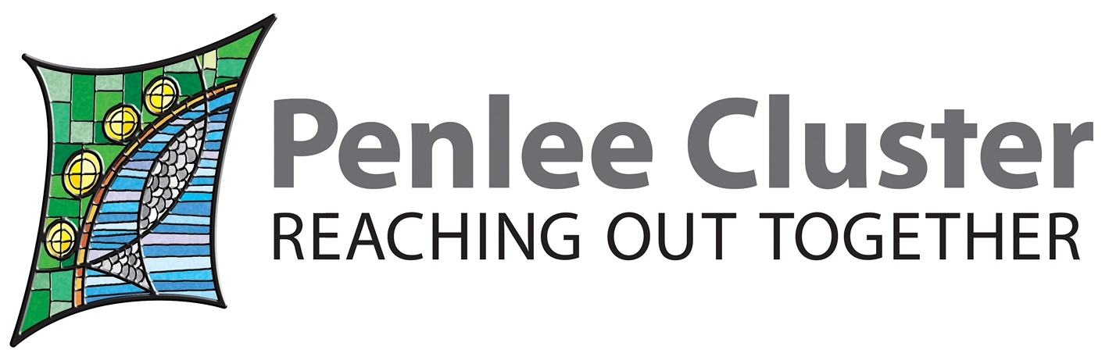 | The Penlee Cluster Support Service for Parents and Families  Covering West Penwith

Please complete this form for referral to The Penlee Cluster support service for parents and families covering West Penwith. The information provided will help us to figure out what your support needs are and how our service can help you and your family.

Personal Details

Current location:

Full Name:

Address:

Postcode: | Phone number:
Email address:

Names of other members of your household:
Name:  Date of birth:  Age:  Male/Female/Prefer not to say  Nationality:  Relationship to You: | Name:  Date of birth:  Age:  Male/Female/Prefer not to say  Nationality:  Relationship to You
Name:  Date of birth:  Age:  Male/Female/Prefer not to say  Nationality:  Relationship to You: | Name:  Date of birth:  Age:  Male/Female/Prefer not to say  Nationality:  Relationship to You:
Brief outline of current circumstances:

Are you employed?

Do you attend college / training courses?

Please give details of the following where relevant:

Any past or current mental health issues:

Any other health issues:

Any other professionals working with you:

Support Needs

All people who receive a service from us have a support plan that helps us to identify their needs which helps shape the support we can offer.

What are your support needs?

Low need -- High need

Economic Wellbeing 1 2 3 4 5
Understanding or claiming benefits
Help with council tax / housing benefit / UC
Budgeting / managing money

Training, Education and Employment
Getting information about accessing education / training / work
Support with job centre appointments
Help with creating a CV
Looking into / applying for child care

Health
Accessing health services
Physical health
Mental health
Managing your alcohol or drug use
Communication
Help with speaking to other agencies
Accessing the community
Support with attending baby groups
Support with accessing hobbies: Gym, fitness classes, groups
Any other support required:

Risk Assessment

When/Date

Physical Health/Disability Yes No ………………..
Suicide/suicidal thoughts or threats of Yes No ………………..
Self-harm Yes No ………………..
Misuse of drugs/alcohol Yes No ………………..
Risk to others due to drug/alcohol use Yes No ………………..
Self-Neglect Yes No ………………..
Risk from others (partner, family, friends) Yes No ………………..
Risk to others Yes No ………………..
Victim of harassment Yes No ………………..
Risks relating to mental health issues Yes No ………………..
Violence to other persons Yes No ………………..
Criminal offences Yes No ………………..

How we use your information

The personal and sensitive personal information that is collected on this form will only be processed in connection with your application to support from us. Your personal information will be kept securely on our systems. At times it will be necessary to share your information with other organisation’s involved in your case, for example, social services, the police, health services and any other relevant organisations. On these occasions the information will only be shared either with your agreement or if there is a legal reason to do so, and the information will be limited to the amount required for that purpose.

Declaration

I authorise The Penlee Cluster to share any information which may be reasonably asked for in connection with my application for support from The Penlee Cluster.

All the answers and information I have given in this application are true to the best of my knowledge. I understand that if I give false information, The Penlee Cluster may refuse or withdraw the service. If my circumstances change in any relevant way I will let you know.

Signed Date

Please return to: The Penlee Cluster ; Family worker

molly.blewett@penleecluster.org.uk

